A Solution to the Isolated-Source Vibration Problem Based on MATLAB

Yuchen Song Student No.201830360498

# Introduction

This project is aimed at solving an isolated-source vibration problem. In the problem, there is a machine element supported by springs and connected to a dashpot is subjected to a periodic force. We are then asked to play with an interesting term, transmissibility, defined as the ratio of the maximum value of the fluctuating periodic force transmitted to the foundation to the maximum value of the periodic force applied to the machine element.

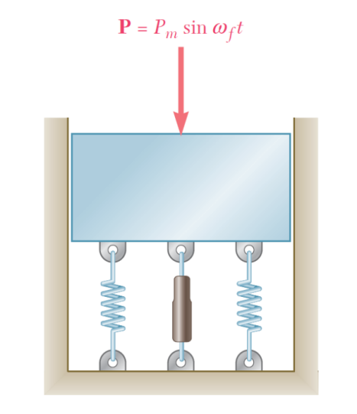

Figure 1 The diagram for the problem

# Solutions

## Fm and Tm

In the free body diagram (FBD) shown below, a set of equations can be generated. From these equations, we can do some algebraic transformation and get the expression of Fm and Tm[1], with and $(c/c_{c}, we use ζ here for convenience)$ as parameters.

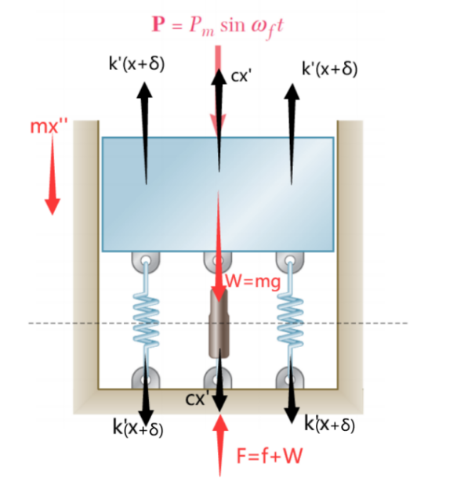

Figure 2 Free body diagram

$$\begin{aligned}\left\{\begin{aligned}k=2k^{'} \\ +↓ mg-2k^{'}δ=0 \\ +↓ mg+P-2k^{'}\left(x+δ\right)-{cx}^{'}={mx}^{''}\end{aligned}\right. ⇒ {mx}^{''}+{cx}^{'}+kx=P_{m}\sin\left(ω_{f}t\right)\#\left(1\right)\end{aligned}$$

$$\begin{aligned}\left\{\begin{aligned}k=2k^{'} \\ F=f+mg \\ +↓ 2k^{'}\left(x+δ\right)+{cx}^{'}-F=0\end{aligned}\right. ⇒ f={cx}^{'}+kx\#\left(2\right)\end{aligned}$$

$$(1) ⇒ x=x_{m}sin(ω_{f}t-φ)$$

$$⇒ x'=ω_{f}{⋅x}_{m}cos(ω_{f}t-φ)$$

$$∴ (2) ⇒ f={cω}_{f}{⋅x}_{m}cos(ω_{f}t-φ)+kx_{m}sin(ω_{f}t-φ)$$

$$=x_{m}\sqrt{{({cω}_{f})}^{2}+k^{2}}⋅sin(ω_{f}t-φ+t)$$

$$=x_{m}k\sqrt{{({2ζω}_{f}/ω_{n})}^{2}+1}⋅sin(ω_{f}t-φ+t)$$

$$\begin{aligned} ⇒ F_{m} =x_{m}k\sqrt{{({2ζω}_{f}/ω_{n})}^{2}+1}\#(3)\end{aligned}$$

We have $\frac{x_{m}}{P_{m}/k}=\frac{1}{\sqrt{{\left(1-{(ω_{f}/ω_{n})}^{2}\right)}^{2}+{\left({2ζω}_{f}/ω_{n}\right)}^{2}}}$

$$∴ (3) ⇒ T_{m}=F_{m}/P_{m}=\frac{\sqrt{{\left(2ζω_{f}/ω_{n}\right)}^{2}+1}}{\sqrt{{\left(1-{(ω_{f}/ω_{n})}^{2}\right)}^{2}+{\left(2ζω_{f}/ω_{n}\right)}^{2}}}$$

## Plotting

Now that we’ve gotten the expression of $T_{m}$, we’re able to calculate and plot the value of it under different situations (i.e., with different ${ω_{f}/ω}_{n}$, and different $ζ$).

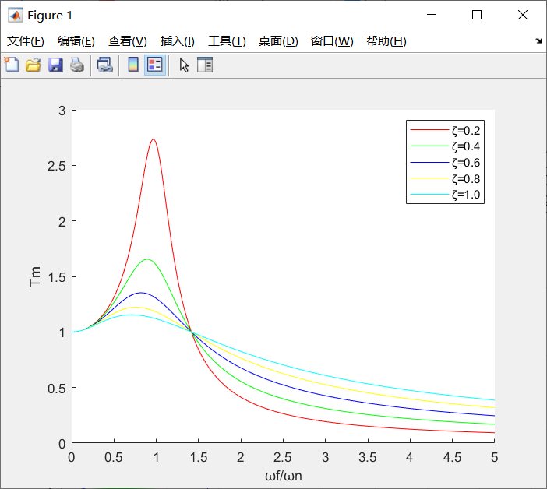

Figure 3 Tm-frequency ratio curve

## Appropriate $ζ$ (Solution: $ζ≤0.5605$)

From the plot, it is quite clear that when ${ω_{f}/ω}_{n}=2.5$, the higher the $ζ$ is, the larger Tm will be(i.e., they are positively correlated). So, all I need to do is to find the critical $ζ$, where Tm exactly equals 0.5. I wrote another script and with the help of MATLAB, I find the solution “x=0.5605” quickly. So, the answer to question (b) should be $ζ≤0.5605$.

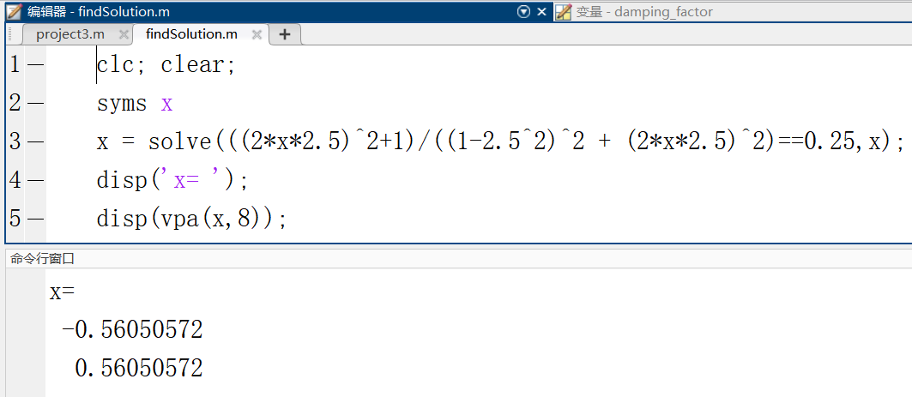

Figure 4 Solutions in console

# Discussion

From the plot we draw above, the curve firstly rockets up and then plummets down dramatically when the frequency ratio varies between 0 and $\sqrt{2}$, and all curves converges at the point $(\sqrt{2}, 1)$. It suggests that when the frequency ratio is smaller than $\sqrt{2}$, the maximum force transmitted to the foundation is even larger than the maximum force applied to the object(i.e., it cannot achieve the goal of isolating the vibration). As for $ζ$, we can infer that the smaller the $ζ$ is, the better the isolating effect will achieve.[2]

Meanwhile, I find the curve very similar to the magnification factor plot we’ve learnt in class, that is because the expression of transmissibility and the expression of magnification factor share the same nominator, and their value tends to infinite when frequency ratio is 1 and damping factor approaches 0.

# Conclusion

In this project, I dig into a vibration source isolating system, calculating and plotting the expression of the transmissibility versus frequency ratio under the situations of different damping ratios. What’s more, I find some interesting conclusions based on the plot, which can be used in further research.

# Code

Part I

|  |
| --- |
| %Author Yuchen Song  %2021/06/17 20:42  clc;clear;  hold on;  frequency_ratio = 0:0.01:5;  damping_factors = [0.2:0.2:1];  colors = ['r','g','b','y','c'];  for i=1:length(damping_factors)  c = colors(i);  Tm = sqrt((2*damping_factors(i).*frequency_ratio).^2+1) ...  ./sqrt((1-frequency_ratio.^2).^2 + ... [3]  (2*damping_factors(i).*frequency_ratio).^2);  plot(frequency_ratio, Tm, c);  end  legend('ζ=0.2','ζ=0.4','ζ=0.6','ζ=0.8','ζ=1.0');  xlabel('ωf/ωn');  ylabel('Tm'); |

Part II

|  |
| --- |
| clc; clear;  syms x  x = solve(((2*x*2.5)^2+1)/((1-2.5^2)^2 ...  + (2*x*2.5)^2)==0.25,x);  disp('x= ');  disp(vpa(x,8)); |

# References

I’ve referred some online websites and articles for inspiration. Special thanks for the help of them.

1. <https://cdn.chegginfo.com/aa4b16dd-3b94-4f49-885c-28e2996eb4da.html>
2. Zou, Xicong & Li, Zengqiang & Zhao, Xuesen & Sun, Tao & Zhang, KunPeng. (2014). Study on the auto-leveling adjustment vibration isolation system for the ultra-precision machine tool. Proceedings of SPIE - The International Society for Optical Engineering. 9281. 92812L. 10.1117/12.2069463.
3. <https://www.mathworks.com/matlabcentral/answers/158522-how-do-i-plot-this-function-in-matlab>